Step to clone a repository on Github
Step 1: Visit the Github repository you would like to clone (https://github.com/OUCRU-Modelling/R-cafe)
Step 2: Click on code -> select HTTPS -> copy the link in the URL
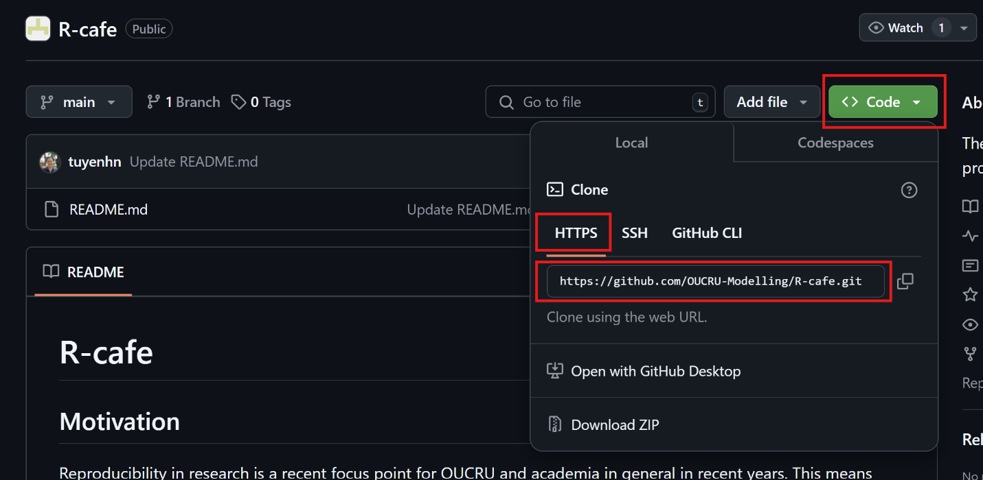
Step 3: Open Github Desktop then choose file -> Clone resipotory
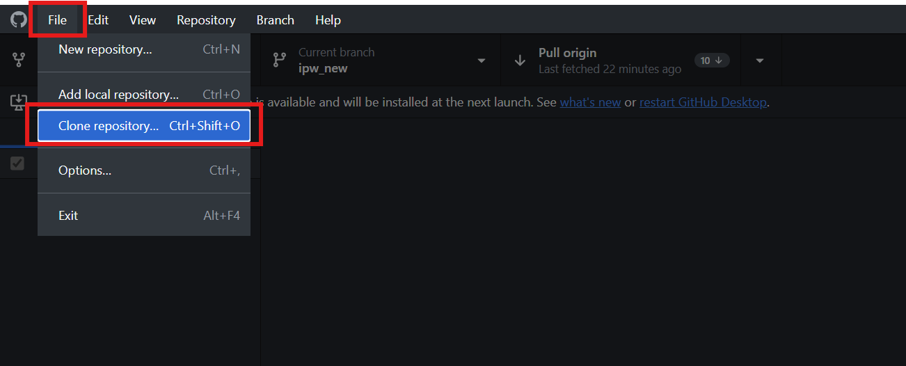
Step 4: Choose URL -> paste the copied link to the blank below the hub/cool-repo -> Change local path to the directory you prefer or it will use default directory -> Click clone
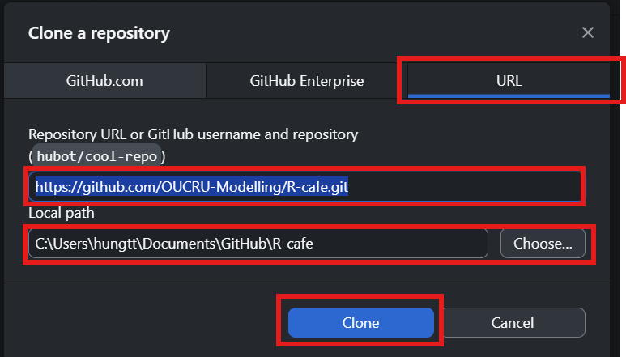
Step 5: Check if the repository has been cloned to correct place
